Title | Software Subsystem Design Description <Coordinator Subsystem>
Distribution | Software Archive
Author | Kelly-DongMing Li | Date | 2021-02-07
Review | See review section | Date | See review section
Approved |  | Date
Remarks

Contents
1 Context 4
1.1 Overview 4
1.2 Use Case Diagram 4
1.3 Subsystem Definitions 5
1.4 Acronyms and Abbreviations 6
2 Data Sheet 7
3 Detailed Description 8
3.1 Static Modelling 8
3.2 Dynamic Modelling 9
3.2.1 Overall Cooperation Diagram 9
3.3 Class Design 10
3.4 Detailed Design 11
3.4.1 System initialize 11
3.4.2 Tasks 13
3.4.2.1 Task List 13
3.4.2.2 MainTask 13
3.4.2.3 WatchdogTask 14
3.4.2.4 FrontendTask 14
3.4.2.5 HartTask 14
3.4.2.6 ServicesTask 15
3.4.2.7 SlowTask 16
3.4.2.8 CPULoadTask 17
3.4.2.9 Application program interface 17
3.4.3 Watchdog 17
3.4.3.1 Watchdog Description 17
3.4.3.2 Watchdog Implement 17
3.4.3.3 TriggerWatchdog_CDT 18
3.4.4 Cpu Load Calculation 18
3.4.4.1 Measure CPU Load 18
3.4.4.2 Implementation 19
3.4.4.3 UpdateCpuLoad 19
3.4.5 FE Communication 19
3.4.6 Variable Calculation 20
3.4.6.1 Calculate frequency 20
3.4.6.2 Calculate temperature 20
3.4.7 Variable Updated 20
3.4.7.1 UpdateInternalTemperature_CDT 20
3.4.7.2 UpdateSteamEnthalpy_CDT 20
3.4.7.3 UpdateMaxTemperature_CDT 20
3.4.8 Password Management 20
3.4.8.1 GetFunctionPasswd 21
3.4.9 Time Calculation 21
3.4.9.1 CalculateElapsedTime 22
3.4.9.2 UpdateWorkingTime_CDT 22
3.4.10 Function execution sequence monitor 22
3.4.11 NV Start-up 23
3.4.11.1 StartupNVSubsystem 24
3.4.11.2 FormatAllData_intern 24
3.4.12 Diagnosis Information Update 24
3.4.12.1 UpdateDiagnosis 25
3.4.13 Data protect 25
3.4.13.1 Duplicated data 25
3.4.13.2 Check Data CRC 25
3.5 Design Decisions and Limitations 25
3.6 Hardware Dependencies 25
3.7 Data Object Description 25
References 30
Revision History 30
Design review 30

List of Figures
Figure 1: Use Case Diagram for Coordinator subsystem 5
Figure 2: Context Diagram for Coordinator subsystem 9
Figure 3: Sequence diagram for Coordinator 10
Figure 4: Coordinator subsystem class diagram 11
Figure 5: system initialize flow diagram 12
Figure 6: Main Task operation 14
Figure 7: Service Task flow diagram 15
Figure 8: Slow Task operation 16
Figure 9: Watchdog collaborate diagram 18
Figure 10: Time calculation flow chart 21
Figure 11: Program Flow monitoring of Critical Path 23

List of Tables
Table 1: Task List 13
Table 2: Front End commands in coordinator 19
Table 3: Data Objects Table 25

Context

This document is a representation of analysis, planning, implementation and decision-making for the VT5 project’s Coordinator subsystem.

Overview
This document describes the functional design specification for the Coordinator subsystem of VT5 (for reqiurements, see Coordinator Subsystem Requirements Specification [1]).

The Coordinator subsystem is the central subsystem which interacts with all other subsystems in the devices. The main functionalities of Coordinator is to implement：
- Initializing function:
- Initialize hardware
- Initialize EmbOS
- Initialize NV
- Initialize all subsystems
- Check password of special application
- Create tasks
- Scheduling function:
- Task management
- Subsystem internal function:
- Hardware Watchdog and Software watchdog monitor.
- Time management
- FE communication.
- Calculate working time.
- Calculate CPU load.
- Update diagnosis information (include NV and FE alarm).
- Scheduling process variable calculation.
- Operating mode management
- Update HMI display

Use Case Diagram

The following Use Case diagram illustrates the top-level uses derived in the Coordinator subsystem Requirements Specification [1]).

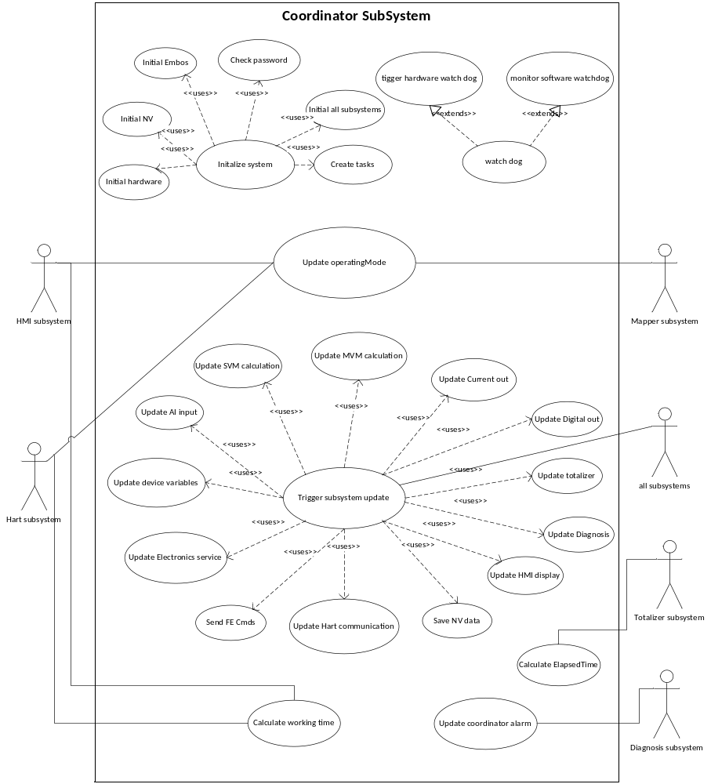
Figure 1: Use Case Diagram for Coordinator subsystem

Subsystem Definitions

Diagnostic Subsystem | VT5 subsystem responsible for handling error conditions and warnings. Also provides General Alarm data for the Digital Output subsystem.
HART Subsystem | VT5 subsystem for interfacing to HART (Highway Addressable Remote Transducer) protocol communications.
HMI Subsystem | VT5 subsystem providing Human Machine Interface for local user access via display and key input.
NV-RAM Subsystem | VT5 subsystem responsible for read / write access and maintenance of non-volatile memories (in transmitter and sensor).
MVM Subsystem | VT5 subsystem for providing volume/mass and operation mode to local user and other subsystems. UOM Subsystem supports the Digital Out with the Units Conversion Factors.
SVM Subsystem | VT5 subsystem for providing Single Variable Measurement
Mapper Subsystem | VT5 subsystem for mapping the device variable to HART dynamic variable
FrontendInterface Subsystem | VT5 subsustem for exchange data with Frontend board.
Electronic Services | VT5 subsystem for providing ram/rom check, temperature/ DIP switch check.
CurrentOut Subsystem | VT5 subsystem for setting current out value to output PV percent value,or alarm value.
Digital Output subsystem | VT5 subsystem for setting frequency value to output PV percent value,or totalizer value,or alarm value
EmbOS | An embedded operating system for the development of real time application for a variety of microcontrollers.
ServicePort subsystem | VT5 subsystem for providing communications like HMI & HART for service engineer base on HMI connectors.
Totalizer Subsystem | VT5 subsystem providing calculation of accumulative total, such as volume, mass, energy and so on.

Acronyms and Abbreviations

HART | Highway Addressable Remote Transducer
HMI | Human Machine Interface
N/A | Not Applicable
NV | Non-volatile
TBD | To Be Determined
FE | Frontend
CB | Communication Board
VT5 | Vortex flow meter 5
RTOS | Real time operation system
CDT | Coordinator subsystem
CO | Current out subsystem
DO | Digital out subsystem
IO | Input / output

Data Sheet
This chapter gives an overview about all important facts of the subsystem. It can be used by a developer who would like to reuse this subsystem.

Category | Item | Description
Development | Version / Status | Release
Development | Known Bugs | Not known
Development | Planned Improvements | None
HW-Platform | Type | M16C63
HW-Platform | Clock | 3.6MHz
SW-Development Environment | Compiler | IAR for M16C, V3.4
SW-Development Environment | Operating System | Segger embOS for M16C version 3.28g
SW-Development Environment | Case / Code-Generation Tool | EntryTool 1.1.3
Required Resources | Operating System | Use coordinatorDataSemaphore as OS semaphore.  Use the OS_GetTime32(void) function to get the system time.  Use OS_CREATETASK() function to create the tasks.
Required Resources | HW | I/O Port0_7:  Coordinator uses I/O Port0_7 to trigger external hardware watch dog MAX824. (for details, see MAX823-MAX825Z.pdf [2]).  I/O Port10_2  Coordinator uses the port to test whether need to format NV.
Required Resources | RAM | 6167 bytes
Required Resources | NVRAM (Plant) | 98 bytes
Required Resources | ROM | 16470 bytes
Required Resources | Execution Time | Fast path(main task) : about 30ms  Slow path(slow task): about 800ms
Required Resources | Subsystems | - SVM  - MVM  - Diagnosis  - Mapper  - HMI  - HART  - FrontendInterface  - Current out  - Digital out  - ElectornicServices  - ServicePort
Required Resources | Data Objects | TABENUM8  T_DIAGNOSIS_ALARM  SIMPLE objects  FLOAT  For detail, Please refer Data Object Description
Required Resources | Safety | Need HW and SW Watch dog.  1. HW Watch dog scouts the application run well.  2. SW Watch dog scouts the all tasks run well.  3. monitor code execution.
Standards | Other | None
Standards | Requirements / Use Cases | Please refer to USE CASE
Documentation | Public Interface Description | Please refer to Application Programmer Interface
Documentation | Test Specification | See [TP009]Software Subsystem Test Plan Coordinator

Detailed Description

Static Modelling

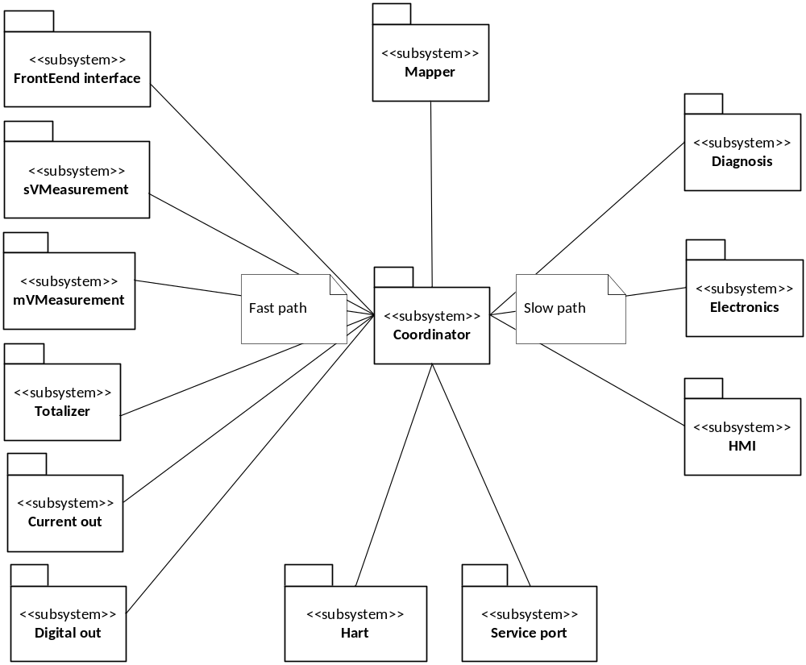
Figure 2: Context Diagram for Coordinator subsystem

Dynamic Modelling

Overall Cooperation Diagram

This diagram represents the overall implementation of Coordinator.
Coordinator shall initialize embos and create MainTask. MainTask will initialize all subsystems and create all other 6 tasks. From then on all the tasks are shceduled by embos in background.
The sequence to initialize the subsystems need to considered. The sequence is：
- Inilize hardware and start up OS to create and start up the main task.
- In the main task, inilize and start up the watch dog to trigger the HW watch dog. It will prevent the CPU be reset by the esternal HW watch dog.
- Initialize the ElettornicService subsystem to check whether the CPU is OK.
- Initialize the FE subsystem to power on the FE board. FE application will start up with the CB application at the same time.It saves the begin time.
- Start up NV subsystem to initialize the NV data. It prepare for initializing the subsystems.
- Initialize the all other subsystems.
- Create the other tasks.

Coordinator shall initialize embos and create MainTask. MainTask will initialize all subsystems and create all other 6 tasks. From then on all the tasks are shceduled by embos in background.
The

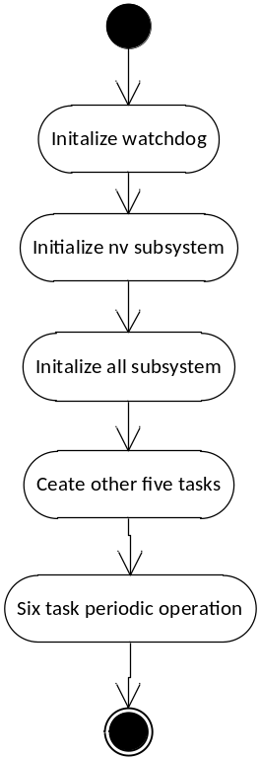
Figure 3: Sequence diagram for Coordinator

Class Design
The object-oriented design approach implies that object method calls include the address of the object’s data structure. This has not been shown in the diagrams although the C implementation requires the address to be supplied manually. The parameter for this is referred to as the “me” pointer.
eg
TUSIGN16 Get_T_UNIT (const T_UNIT SLOW *me, TUSIGN16 objectIndex,
TINT16 attributeIndex, void FAST *ptrValue);
TUSIGN16 Put_T_UNIT (const T_UNIT SLOW *me, TUSIGN16 objectIndex,
TINT16 attributeIndex, void FAST *ptrValue);

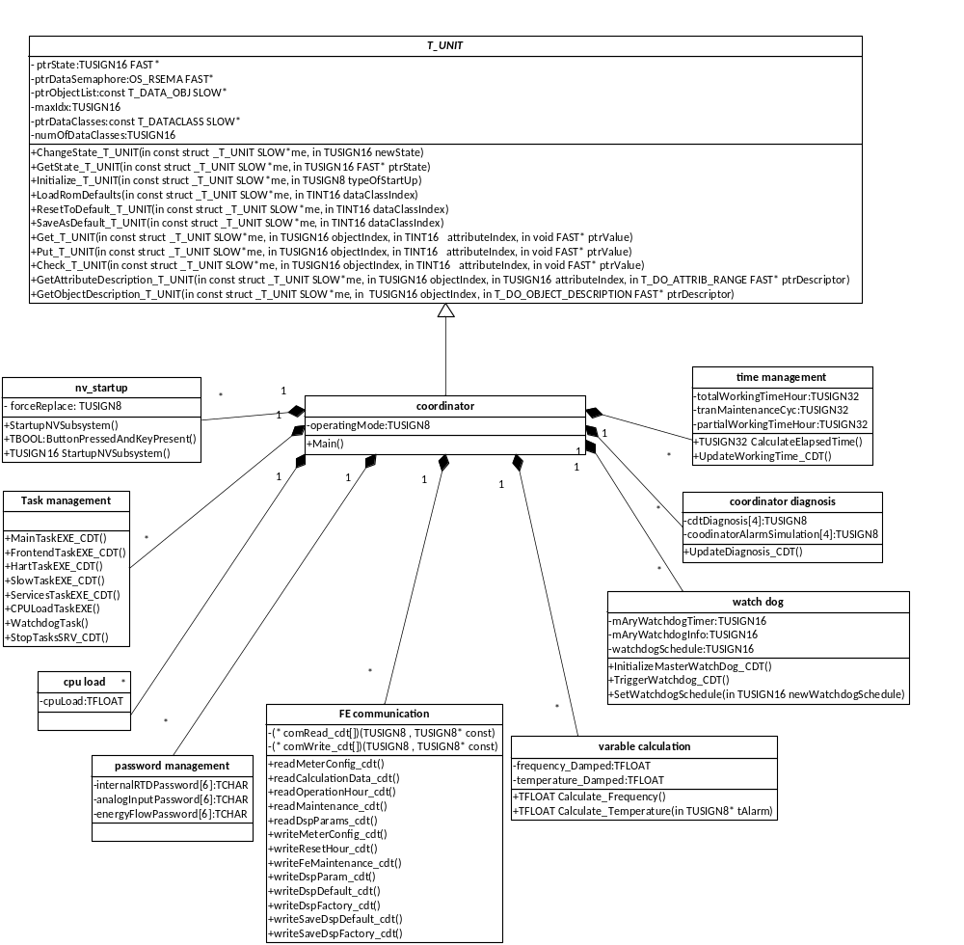

Figure 4: Coordinator subsystem class diagram

Detailed Design

System initialize
Before all tasks are created, the system shall initialize to run multiple tasks. It includes two parts. First, initialize hardware. Second, OS initial and create main task. Figure shows the sequence of system initializes.

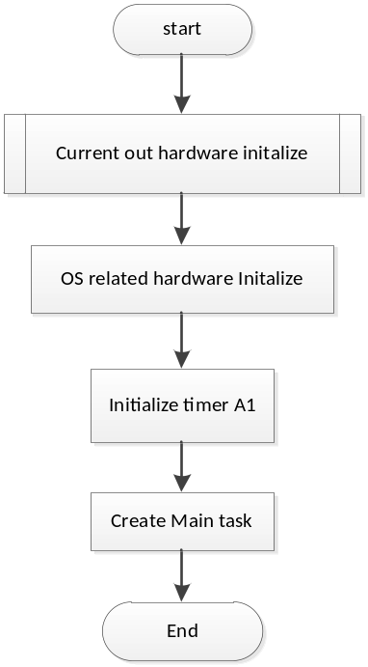

Figure 5: system initialize flow diagram
Timer B5 is dedicated for OS time tick, and ticks every 2ms. Timer A1 is dedicated for time calculation to get precise time.

Tasks

Task List
Table 1: Task List
NO | Task Name | Priority | Stack Size | Description
1 | MainTask | 200 | 1132 | Main thread for the device:part of variable calculation, Current out, Digital out ,Totalizer etc.
2 | WatchdogTask | 250 | 512 | WatchdogTask trigger HW watch dog and monitor tasks status.
3 | FrontendTask | 180 | 768 | FrontEndInterface communication – command process.
4 | HartTask | 160 | 768 | Dedicated for HART commmunication
5 | ServicesTask | 100 | 1320 | Service port activation or select HMI execution
6 | SlowTask | 50 | 1536 | Background task for NV, Transmitter working time, update ES subsystem and update diagnosis status etc.
7 | CPULoadTask | 20 | 256 | calculate CPU no load time and set the status whether ready to calculate CPU Load.

MainTask
The main task will initializes all subsystem and create other six tasks.
Main task includes following functions:
  - Trigger software watch dog.
  - Initialize all subsystem
  - Process variable calculation
  - Manage operating mode
  - Calculate elapse time
  - Update totalizer
  - Update Current Out
  - Update Digital Out
The main task is fast path of the system, and all functions shall be updated very 100ms. Figure 10 shows the main loop of the task.
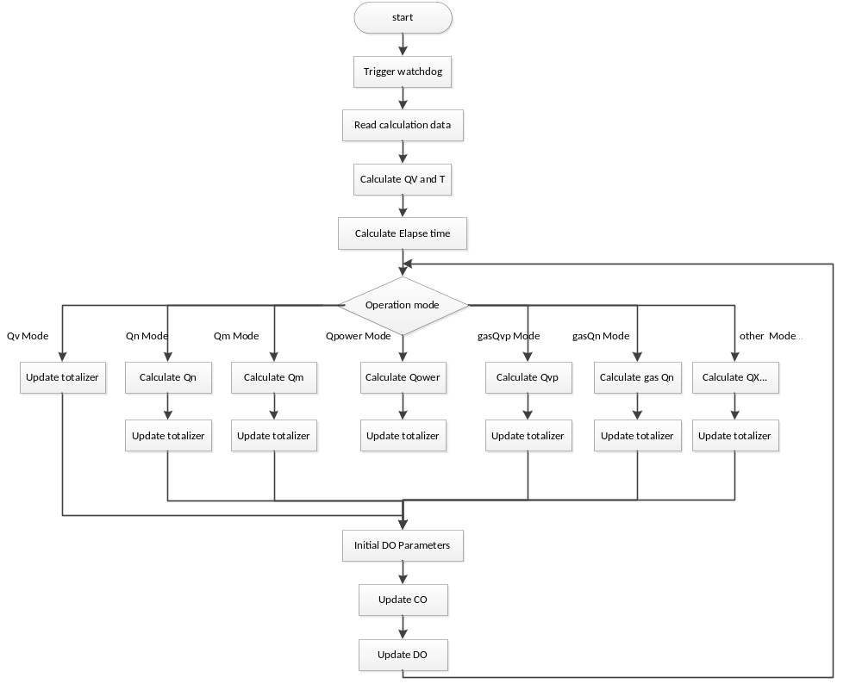
Figure 6: Main Task operation

WatchdogTask
WatchdogTask will trigger HW watch dog and monitor tasks status.Watchdog Task loops very 800ms.
First, it will call the TriggerWatchdog_SYSTEM method to trigger HW watch dog.
Second, the mAryWatchdogTimer value will minus 200( 200tick is 400ms) periodically in WatchdogTask. But the value will be updated to 5000 in the other task if the task run well. if the task can not run correctly in 10s, the mAryWatchdogTimer value will be minused to zero, and WatchdogTask can check the value .If more than one task does not run(mAryWatchdogTimer is zero), the bite_action will be triggered. If one task halts more than 10s SW watchdog will execute the bite-action. Details see chapter 3.4.3.

FrontendTask
First, this task will trigger software watch dog then poll the FrontEndInterface command request.if there is any commands in the mailbox, process those commands. The time interval of this task is 50ms

HartTask
HART task will poll the HART command request from layer 7 whether there is some HART commands are received successfully.It will trigger sofeware watch dog also. This task will be executed again by OS after a delay time about 100ms.

ServicesTask
This task is responsible for the selection of the HMI port function or service port function because they share the same UART port. This task will be executed again by OS after a delay time about 100ms.
- If the service port pin is connected task will execute ServPortCommandInterpreterEXE.
- Else, task will assign the port to HMI. The HMI includes physical HMI and remote HMI.
Figure 7 show the sequence of service task execution.
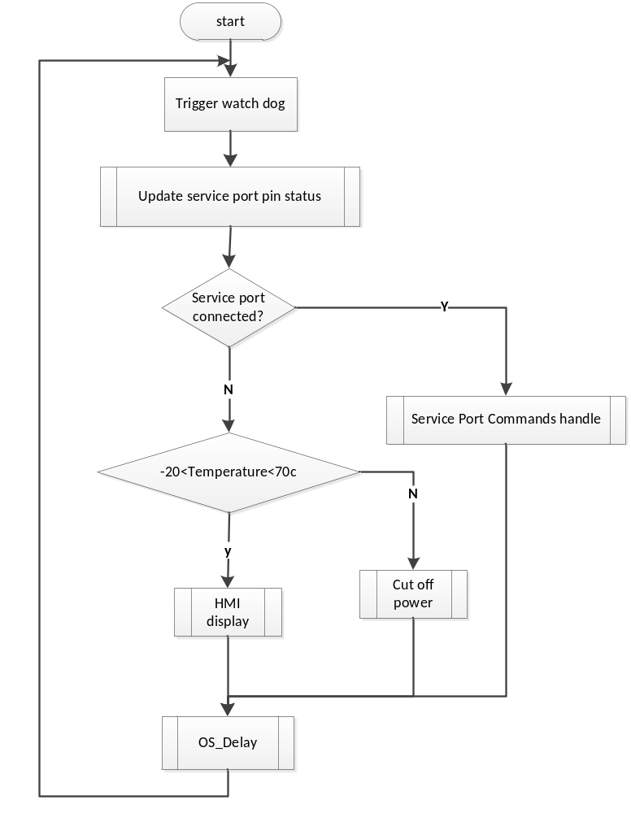
Figure 7: Service Task flow diagram

SlowTask
Slow task is a background task. it have low priority.It will trigger software watch dog, save NV data, calculate working time, update diagnosis alarm and update ElettornicServiec subsystem every 500ms.

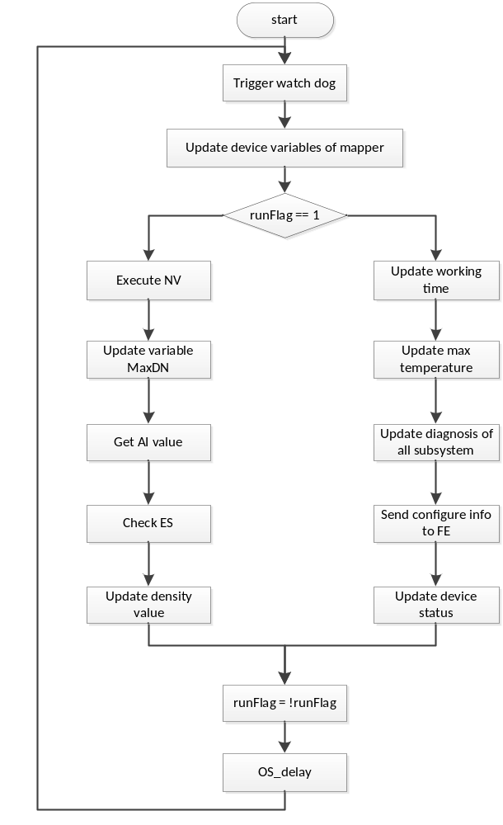
Figure 8: Slow Task operation

CPULoadTask
This task will calculate cpuLoadBaseTime and enable calculate first. It will totalize the cpuLoadCount value only next. Details see chapter3.4.4.

Application program interface
Name: void MainTaskEXE_CDT(void)
This function is Main task entry function.

Name: void HartTaskEXE_CDT(void)
This function is Hart task entry function.

Name:void FrontendTaskEXE_CDT(void)
This function is Frontend task entry function.

Name:void ServicesTaskEXE_CDT(void)
This function is Services task entry function.

Name:void SlowTaskEXE_CDT(void)
This function is Slow task entry function.

Name:void CPULoadTaskEXE(void)
This function is CPULoad task entry function.

Name: void StopTasksSRV_CDT(TUSIGN16 taskIdx)
Param: taskIdx; the parameter appoint to the task to be stopped
This is the function to stop the task. It will stop the task after disabling the task’ software watchdog BiteAction.

Watchdog

Watchdog Description

The objectives for watchdog are:
- To detect an operating system failure that is preventing some or all tasks from running
- To detect an infinite loop in any of the tasks
- To detect deadlock involving two or more tasks
- To detect if some lower priority tasks are not getting to run because higher priority tasks are hogging the CPU

Watchdog is a timer that must be triggered to restart the countdown before reaching zero. Otherwise the watchdog will start a defined action (“the watchdog bites action”). Watchdog handles a list of software-watchdogs. For each software-watchdog, a function (“the watchdog bites action”) must be defined. When watchdog bites, expected actions link to the software watchdog will happen.

Watchdog Implement
The watch dog implementation is divided in two parts – HW watchdog and software watchdog.
- First, there is a HW-watchdog implementation, a singleton, which is an active object that means it has an own task. The task runs with the highest priority. Each time all software-watchdogs are scheduled and the hardware-watchdog will be triggered by output a pulse with port0_7. The hardware-watch will reset the CPU if it is not triggered per 1.6 seconds. (For details, see MAX823-MAX825Z.pdf [2]).The application is responsible to distinct between power-on-reset and watchdog-reset.
- Second, the SW-watchdog class that could have many instances. The application defines a SW-watchdog to supervise real-time behavior or to detect deadlocks of tasks. The deadlock time is set to 10s about now. If the SW -watchdogs are not triggered, than the defined bite-action will be called. The bite-action runs inside the watchdog-task with highest priority. If one task halts more than 10s, SW watchdog will execute the bite-action.
For the watch dog detail process refers to Figure 9: Watchdog collaborate diagram.

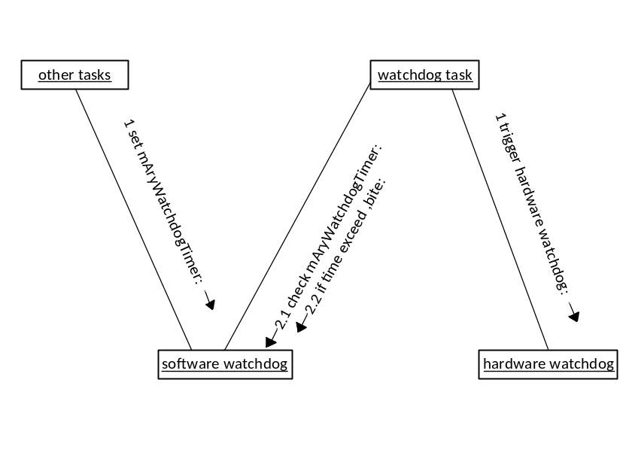
Figure 9: Watchdog collaborate diagram

TriggerWatchdog_CDT
Name: void TriggerWatchdog_CDT(T_BITEACTION BiteAction, TUSIGN16 ms, TUSIGN16 info)
Param: BiteAction ; the parameter appoint to which task BitAction
ms ; the task watchdog schedule time value
info ; the info of the task BiteAction
This is the function to update mAryWatchdogTimer value. The value will be used in WatchdogTask. The method will be called in each task except WatchdogTask and CpuLoadTask.

SetWatchdogSchedule

Name:void SetWatchdogSchedule(TUSIGN16 newWatchdogSchedule)
Param: newWatchdogSchedule ; the new watchdog schedule time value

This is the action function to reset partial working time value.

Cpu Load Calculation

Measure CPU Load

CPU load is one key indicator for real time system, which to measure the system response time and real time performance.
The way to measure CPU load is to use one statistic task to calculate. The priority of CPULoad task is just higher than idle task. This will make sure that CPULoad task will work only when CPU is in idle status. When this task is running, it will disable task switching, and this task will execute all the time until it enable task switching;
CPULoad task will count a certain number(whole_Count) and get the execute time for the count number as the baseTime. Then it will enable task-switching, when all tasks operate in normal case, Cpuload will count when all task is not in ready status. Then we can get the cpuload for a certain time. For example, for about 1 sec, we can get the actual during time (fullTime) through OS_Time( M16C timer), and also get the CpuLoad count number (new_Count). Then we can use the following formula to calculate the CPULoad.

Idle_Time = baseTime/ whole_Count * new_Count
CpuLoad = (fullTime- Idle_Time)/ fullTime

This is the function to calculate CPULoad. It will get the CPU free time count and the full time to calculate CPULoad per second. It will be called by MainTask of Coordinator subsystem.

Implementation
- Create a task with the lowest priority to calculate the free time count. If all other task halt ,the task will accumulate count of the free time.
- In case CPULoad task did not get the execute time in a long time, and cpuload could not be updated in those time. We use the maintask to call the calculation method, and update the cpuload. The formula above is used to calculate CPULoad, after each calculation, the cpuload accumulate count will be cleared for next calcultion.
- The idle execute time shall be stored in NV in case CPULoad will stop all other tasks to get this idle execute time each time when power up.

UpdateCpuLoad

Name: void UpdateCpuLoad_CDT(void)

This is the function to calculate CPULoad. It will get the CPU free time count and the full time to calculate CPULoad per second. It will be called by MainTask of Coordinator subsystem.

FE Communication
Coordinator sends commands to Front end board to get information. Those read and write commands include:

Command index | Read/Write | Command content
0x00 | R | CDT_READ_METER_TYPE
0x01 | R | CDT_READ_CALCULATION_DATA
0x04 | R | CDT_READ_OPERATION_HOUR
0x06 | R | CDT_READ_FE_MAINTAIN_CYCLE
0x07 | R | CDT_READ_DSP_PARAM_CMD
0x0A | R | CDT_READ_SPAN_UPPERRANGE
0x0E | R | CDT_READ_AUTOSELFDIAG_EN
0x0F | R | CDT_READ_OUTPUT_FILTER_ALG
0x10 | R | CDT_READ_OUTPUT_FILTER_PARA
0x00 | W | CDT_WRITE_METER_TYPE
0x04 | W | CDT_WRITE_RESET_OP_HOUR
0x06 | W | CDT_WRITE_FE_MAINTAIN_CYCLE
0x07 | W | CDT_WRITE_DSP_PARAM_CMD
0x08 | W | CDT_WRITE_DSP_DEFAULT
0x09 | W | CDT_WRITE_DSP_FACTORY
0x0A | W | CDT_WRITE_SAVE_DSP_DEFAULT
0x0B | W | CDT_WRITE_SAVE_DSP_FACTORY
0x0D | W | CDT_WRITE_SAVE_REPLACE
0x0E | W | CDT_WRITE_AUTOSELFDIAG_EN
0x0F | W | CDT_WRITE_SPAN_UPPERRANGE
0x10 | W | CDT_WRITE_LOWFLOW_THRESHOLD
0x11 | W | CDT_WRITE_OUTPUT_FILTER_ALG
0x12 | W | CDT_WRITE_OUTPUT_FILTER_PARA
Table 2: Front End commands in coordinator

Variable Calculation
Flow frequency and sensor temperature two variables which is managed in coordinator subsystem. After send CDT_READ_CALCULATION_DATA command to front end board, the frequency and temperature are returned.

Calculate frequency
Name: TFLOAT Calculate_Frequency(void)
Return Value: flow frequency

This method will calculate flow frequency from FE, and update frequency related diagnosis.

Calculate temperature
Name: TFLOAT Calculate_Temperature( void)
Param: none
Return Value: sensor temperature

This method will update damping temperature related diagnosis.

Variable Updated
Base on the original calculated value to update associated variables.

UpdateInternalTemperature_CDT
Name: TUSIGN16 UpdateInternalTemperature_CDT(void)
Return Value: error value

The internal temperture may derive from temperature sensor, simulation value, analog input value, hart input vale and preset value.

UpdateSteamEnthalpy_CDT
Name: TUSIGN16 UpdateSteamEnthalpy_CDT(TUSIGN16 opModeShift)
Return Value: error value

Update steam enthalpy for selection steam power mode.

UpdateMaxTemperature_CDT
Name: void UpdateMaxTemperaute_CDT(void)

The internal temperture is more than recorded maximum, update the recorded maximum temperature.

Password Management

There are three passwords for function validation. There passwords are composed of six chars.
internalRTDPassword is for sensor temperature function validation.
analogInputPassword is for AI function validation.
energyFlowPassword is for energy related operation mode function validation.

GetFunctionPasswd
Name: static void GetFunctionPasswd(TCHAR const *strOrderNum, TCHAR const *strFunctionName, TCHAR *strPassword)
Param: strOrderNum is a pointer to null terminated string (containing order number of device)
strFunctionName is a pointer to null terminated string (containing function name)
strPassword is a pointer to array of password.

This method provides the algorithm of generating passwords.

Time Calculation

Coordinator shall calculate one loop of main task time for totalizer, digital out. This shall provide fine grained elapse time. Timer A1 is dedicated for precise time calculation. Timer A1 is 16 bit timer, and the TIMER_F1F2_CLOCK is set as 1643200L. So the range of timer A1 is 568.88 millisecond, which is larger than one loop of main task.

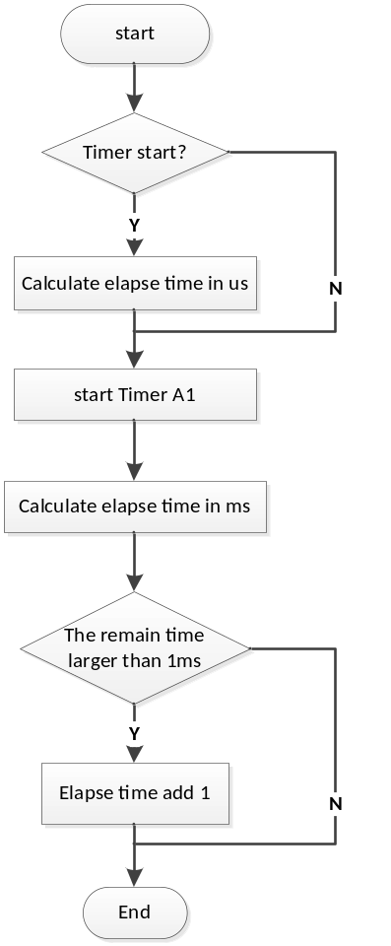
Figure 10: Time calculation flow chart

Coordinator also calculate the device working time include total working time and partial working time. The working time is stored in NV, and will be updated. Working time is coarse grained.
Coordinator will get the working time though OS_Time in a slow task. The working time is based on millisecond, and will be saved in NV with days and milliseconds.
The maintenance cycle time will minus 1 when total day time adds 1. The maintenance cycle time has default value in NV. When maintenance cycle time is not bigger than 0, system will set alarm means that the device should be maintained.

CalculateElapsedTime
Name: TUSIGN32 CalculateElapsedTime(void)
Return Value: the time value in miliseconds

UpdateWorkingTime_CDT
Name: void UpdateWorkingTime_CDT(void)

This is the function to update working time. It calculates the total working time and the partial working time that each time device is power on. It minus the device maintenance time also. It will be called by SlowTask of Coordinator subsystem.

Function execution sequence monitor
For safety requirements; the sequence execution in MainTask, SlowTask and WatchDogTask shall be checked.
- For MainTask; the function execution sequence in MainTask is from signal input, signal measurement, PV mapper, and process diagnosis to current output. The execute sequence shall be checked in the right status in every run cycle.
- For SlowTask; this is task to do self-diagnosis and update diagnosis info to diagnosis subsystem, then diagnosis subsystem could issue alarm to current out in MainTask. It shall update each other subsystem diagnosis first; then to update the system diagnosis for the current out. If it fails, the self-diagnosis could not be well executed.
- For WatchDogTask; the task monitoring the other tasks execution status, if it fails, the tasks could not be monitored.

Coordinator uses flags to check the sequence execution in the 3 tasks.
- It will initialize the sequence flag first.
- Before the execution of each function in critical path will check the execution flag. If the execution flag is right, then execute this function. Otherwise it will reset CPU and go to issue alarm.
- After the execution of this function, it will also set the flag about current function. And let the other functions know that it is executed.
- After all functions are executed, the flag will be checked, and assign new value to ensure the next cycle be well executed.

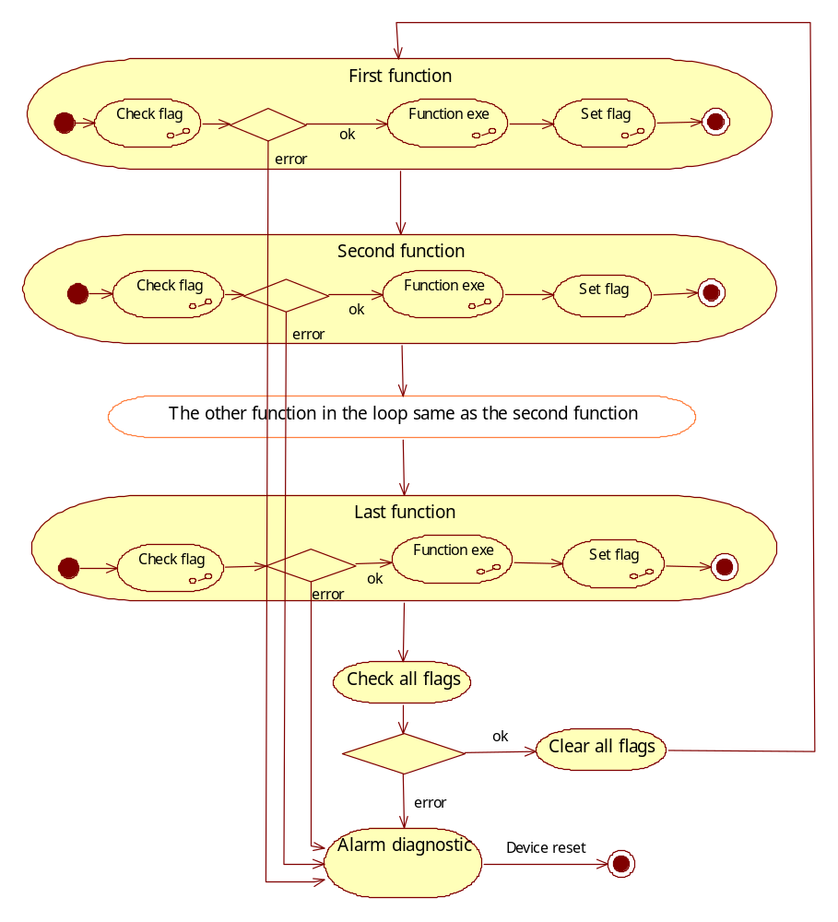
Figure 11: Program Flow monitoring of Critical Path

NV Start-up
Coordinator will start up NV subsystem before start system. It will execute in MainTask.
- It will read the NV data and initialize the system data with NV data.
- It will check whether to format the NV data. If system need to format NV data. First, it will load ROM default data to system data. Second it will format NV data with default data.

StartupNVSubsystem
Name: TUSIGN16 StartupNVSubsystem(void)
Return Value: nvResult ; NV status

Coordinator will start up NV subsystem before start system. It will execute in MainTask.
1. It will read the NV data and initialize the system data with NV data.
2. It will check whether to format the NV data. If system needs to format NV data. First, it will load ROM default data to system data. Second it will format NV data with default data.
3. It will not format calibration segment.

FormatAllData_intern
Name:T_NV_DIAGNOSIS FormatAllData_intern(const TUSIGN16 format)
Param: format ;the NV area scope to be formatted
Return Value: saveResult ;the status of format NV operation

This is the function to load ROM default data and format NV. It will be called in StartupNVSubsystem and ElettronicServices Subsystem.

Diagnosis Information Update
The diagnosis of coordinator subsystem including four parts

- Coordinator will get the NV alarm status to update the diagnostic status. This will be updated in slow task about per 500ms.
- If diagnostic simulation is enabled, coordinator will get the diagnostic simulation alarm and external alarm to update diagnostic status. This will be updated in slow task about per 500ms.
- The alarm information from Front end board.
- The alarm of frequency and temperature exceeds limits.

The detail of alarm is as following:

CDT_ALARM_CB_SIMUDATA 0
CDT_ALARM_CB_ALARM 1
CDT_ALARM_CB_NV_ERROR 2
CDT_ALARM_CB_MAINTENANCE 3
CDT_ALARM_CB_UNCALIBRATED 4
CDT_ALRAM_T_MAX 5
CDT_ALRAM_T_MIN 6
CDT_VORTEX_SENSOR_CIRCUIT_FAILURE 7
CDT_VORTEX_SENSOR_OPEN 8
CDT_VORTEX_SENSOR_SHORT 9
CDT_VORTEX_SENSOR_DRIFT 10
CDT_VIBRAT_SENSOR_CIRCUIT_FAILURE 11
CDT_VIBRAT_SENSOR_OPEN 12
CDT_VIBRAT_SENSOR_SHORT 13
CDT_VIBRAT_SENSOR_DRIFT 14
CDT_SYNC_MISSING 15
CDT_SNR_FAILURE 16
CDT_TEMP_SENSOR_UPPER_LIMIT 17
CDT_TEMP_SENSOR_LOWER_LIMIT 18
CDT_FE_RAM_FAILURE 19
CDT_FE_NV_FAILURE 20
CDT_FE_MAINTENANCE_MATURE 21
CDT_ALARM_REPLACE_FE_TO_CB_BLOCKED 22
CDT_ALARM_REPLACE_REQUIRED_FE_TO_CB_BLOCKED 23
CDT_ALARM_REPLACE_REQUIRED_BOTH_DIRECTION_ENABLED 24

UpdateDiagnosis
Name:void UpdateDiagnosis_CDT(void)

This is the function to update EEPROM status and update Diagnosis alarm. It will call the GetNvDiagnosisNV method to get the EEPROM status and update the NV alarm. Also it will get the Diagnosis simulation status to update the diagnosis alarm.

Data protect

Duplicated data

For the Safety Function, some variables are duplicated. The dynamic variables routine checks the value in both original and duplicated variables. If two values are different, a ram failure or unhandled writing is happened. A device reset is performed.

Check Data CRC
Name: void CheckDataCrc_CDT(void)
This is the function to calculate and check protected data status via CRC function. The ES uses one CRC object to monitor the protected objects status. It will be cyclical called in ElettronicService subsystem.
- When the protected data status is “CDT_CALCULATE”, it will calculate the block protected data CRC value again and change the status to “CDT _PROTECTED”.
- When the protected data status is “CDT _PROTECTED”, it will calculate the block protected data CRC value and compare to the block data CRC object value calculated previously. If the two CRC value is not equal, it will reset the CPU.
- If the protected data status is not “CDT _UNPROTECTED”, it means the protected data status is not right, and it will reset the CPU.

Design Decisions and Limitations
The Coordinator Subsystem is designed base on ABB BUI Common Framework. Use entry tool to generate all the public objects and methods. Tasks scheduling depends on EmbOS.

For all tasks will have different priority and will execute some operation periodically.So operation should be assinged to deffernet task depend on their priority.For example the WatchDogTaskEXE have the highest priority because it will monitor whether the tasks run well. If one task halts more than 10s SW watchdog will execute the bite-action.

Hardware Dependencies
Coordinator uses port0_7 to trigger external hardware watch dog MAX824 (for details, see MAX823-MAX825Z.pdf [2]).

Coordinator use port10_2 as the format NV pin.

Data Object Description

Provide a detailed description of all Data Objects.
Table 3: Data Objects Table
Object name | T_DATA_OBJ |  | Data Class | Storage | Description
coodinatorAlarmSimulation | T_DIAGNOSIS_ALARM | Protected |  | RAM
operatingMode | TABENUM8 | ReplaceStaticRare |  | NON_VOLATILE
workingTimeMSec | SIMPLE_U32 | Unprotected |  | RAM
totalWorkingTimeHour | SIMPLE_U32 | STATIC_CYCLIC |  | NON_VOLATILE
partialWorkingTimeHour | SIMPLE_U32 | Unprotected |  | RAM
simulationMode | TABENUM8 | Protected |  | RAM | Simulation mode
frequency | FLOAT | DynamicDuplicated |  | RAM | Piezo sensor frequency
frequencySim_Enable | TABENUM8 | Protected |  | RAM
frequency_Sim | FLOAT | Protected |  | RAM
frequency_MaxDN | SIMPLE_FLOAT | STATIC_RARE |  | NON_VOLATILE
frequency_MinDN | SIMPLE_FLOAT | STATIC_RARE |  | NON_VOLATILE
frequency_Span | SIMPLE_FLOAT | STATIC_RARE |  | NON_VOLATILE
frequency_Span_Obj | UOM_PF
frequency_range | DEV_RNGFLT | STATIC_RARE |  | NON_VOLATILE
frequency_range_Obj | UOM_PF
frequency_Percentage | SIMPLE_FLOAT | Unprotected |  | RAM
frequency_Damped | FLOAT | DynamicDuplicated |  | RAM
frequency_Damped_Obj | UOM_PF
frequency_UnitCode | TABENUM8 | ReplaceStaticRare |  | NON_VOLATILE
simFrequency_UnitCode | TABENUM8 | ReplaceStaticRare |  | NON_VOLATILE
frequency_UnitType | CONST_U8 | CONSTANT |  | ROM
frequency_Obj | UOM_PF
frequency_SimObj | UOM_PF
frequency_Classification | SIMPLE_U8 | Protected |  | READONLY_RAM
frequency_Status | SIMPLE_U8 | Protected |  | RAM
frequency_DampingTime | FLOAT | ReplaceStaticRare |  | NON_VOLATILE
temperature | FLOAT | DynamicDuplicated |  | RAM
temperatureSim_Enable | TABENUM8 | Protected |  | RAM
temperature_Sim | FLOAT | Protected |  | RAM
temperature_DampingTime | FLOAT | ReplaceStaticRare |  | NON_VOLATILE
temperature_Damped | FLOAT | DynamicDuplicated |  | RAM
temperature_Damped_Obj | UOM_PF
temperature_UnitCode | TABENUM8 | ReplaceStaticRare |  | NON_VOLATILE
simTemperature_UnitCode | TABENUM8 | ReplaceStaticRare |  | NON_VOLATILE
temperature_UnitType | CONST_U8 | CONSTANT |  | ROM
temperature_Obj | UOM_PF
temperatureSim_Obj | UOM_PF
temperature_MaxDN | SIMPLE_FLOAT | STATIC_RARE |  | NON_VOLATILE
temperature_MinDN | SIMPLE_FLOAT | STATIC_RARE |  | NON_VOLATILE
temperature_Span | SIMPLE_FLOAT | STATIC_RARE |  | NON_VOLATILE
temperature_Span_Obj | UOM_PF
temperature_range | DEV_RNGFLT | STATIC_RARE |  | NON_VOLATILE
temperature_range_Obj | UOM_PF
temperature_Percentage | SIMPLE_FLOAT | DynamicDuplicated |  | RAM
temperature_Classification | SIMPLE_U8 | Protected |  | READONLY_RAM
temperature_Status | SIMPLE_U8 | Protected |  | RAM
temperature_Selection | TABENUM8 | STATIC_RARE |  | NON_VOLATILE
intRTDType | TABENUM8 | STATIC_RARE |  | NON_VOLATILE
cpuLoad | FLOAT | Unprotected |  | RAM | CPU load
frontEndConfParamWr | SIMPLE_U8 | Unprotected |  | RAM | Front end configuration parameters
frontEndConfParamRd | SIMPLE_U8 | Unprotected |  | RAM
frontEndTempTypeRd | TABENUM8 | Unprotected |  | RAM
updateTimeFast | SIMPLE_U32 | CONSTANT |  | READONLY_RAM
updateTimeSlow | SIMPLE_U32 | CONSTANT |  | READONLY_RAM
forceReplace | TABENUM8 | Protected |  | RAM
tranMaintenanceCyc | USIGN32 | STATIC_CYCLIC |  | NON_VOLATILE | Transmitter maintenace cycle
vortexDeviceStatus | SIMPLE_U8 | Protected |  | RAM | Vortex family variable status. Hart command 152.
additionalVortexDeviceStatus | SIMPLE_U8 | Protected |  | RAM | Additional vortex family status. Hart command 152.
familyRevision | CONST_U8 | CONSTANT |  | ROM | Hart command 153.
calibrationStatus | TABENUM8 | CalibrationStaticRare |  | NON_VOLATILE | Piezo sensor calibartion status.
internalRTDPassword | SIMPLE_CHAR | CalibrationStaticRare |  | NON_VOLATILE
analogInputPassword | SIMPLE_CHAR | CalibrationStaticRare |  | NON_VOLATILE
energyFlowPassword | SIMPLE_CHAR | CalibrationStaticRare |  | NON_VOLATILE
frequency_Duplicated | FLOAT | DynamicDuplicated |  | RAM
frequency_Damped_Duplictated | FLOAT | DynamicDuplicated |  | RAM
temperature_Duplicated | FLOAT | DynamicDuplicated |  | RAM
temperature_Damped_Duplicated | FLOAT | DynamicDuplicated |  | RAM
temperaturePreset | FLOAT | STATIC_RARE |  | NON_VOLATILE
temperaturePreset_Obj | UOM_PF
cdtDiagnosis |  |  |  |  | cdtDiagnosis byte 0 for cdt
cdtDiagnosis_Duplicated | SIMPLE_U8 | DynamicDuplicated |  | RAM
passwordEnable | SIMPLE_U8 | Protected |  | RAM
temperatureMaxRecord | SIMPLE_FLOAT | STATIC_RARE |  | NON_VOLATILE
temperature_Percentage_Duplicated | SIMPLE_FLOAT | DynamicDuplicated |  | RAM
temperatureAlmRange | RANGEFLT | STATIC_RARE |  | NON_VOLATILE
converterType | TABENUM8 | STATIC_RARE |  | NON_VOLATILE
vortexmeterSize | TABENUM8 | STATIC_RARE |  | NON_VOLATILE
swirlmeterSize | TABENUM8 | STATIC_RARE |  | NON_VOLATILE
snr | FLOAT | Unprotected |  | RAM
frontendOperationHour | SIMPLE_U32 | Unprotected |  | RAM
frontendMaintenance | USIGN32 | Unprotected |  | RAM
vbrCorrectionOn | TABENUM8 | Unprotected |  | RAM
vbrFilStep | INT16 | Unprotected |  | RAM
vbrFilNumCoef | USIGN8 | Unprotected |  | RAM
fcdOn | TABENUM8 | Unprotected |  | RAM
fcdShift | USIGN8 | Unprotected |  | RAM
fcdDelay | USIGN8 | Unprotected |  | RAM
fcdNumCoef | USIGN8 | Unprotected |  | RAM
lockMinIntPeriod | USIGN8 | Unprotected |  | RAM
lockMaxIntPeriod | USIGN8 | Unprotected |  | RAM
lockEstimation | USIGN8 | Unprotected |  | RAM
accuracyHigh | USIGN8 | Unprotected |  | RAM
accuracyMiddle | USIGN8 | Unprotected |  | RAM
accuracyLow | USIGN8 | Unprotected |  | RAM
analogGain | TABENUM8 | Unprotected |  | RAM
gainCtrl | TABENUM8 | Unprotected |  | RAM
gainLowThresh | INT16 | Unprotected |  | RAM
gainHighThresh | INT16 | Unprotected |  | RAM
gainMarginFreq | INT16 | Unprotected |  | RAM
gainMaxShift | USIGN8 | Unprotected |  | RAM
lowFlowThreshOn | TABENUM8 | Unprotected |  | RAM
lowFlowThresh | INT16 | Unprotected |  | RAM
lowFlowThreshCoef | INT16 | Unprotected |  | RAM
noiseSampSize | USIGN8 | Unprotected |  | RAM
staticDecimation | USIGN8 | Unprotected |  | RAM
middleBufDecimation | USIGN8 | Unprotected |  | RAM
maxFlowFreq | FLOAT | Unprotected |  | RAM
minFlowFreq | FLOAT | Unprotected |  | RAM
freqMinMarginPer | USIGN8 | Unprotected |  | RAM
freqMaxMarginPer | USIGN8 | Unprotected |  | RAM
initializeNv | TABENUM8 | Protected |  | RAM
readParameters | ACTION
writeParameters | ACTION
saveCustomerDef | ACTION
saveFactoryDef | ACTION
resetCustomerDef | ACTION
resetFactoryDef | ACTION
resetFE_Runhour | ACTION
temperatureOffsetCorrect | FLOAT | STATIC_RARE |  | NON_VOLATILE
temperatureOffsetCorrect_Obj | UOM_PF
timeStamp | SIMPLE_U32 | Unprotected |  | RAM
actualDensitySelection | TABENUM8 | STATIC_RARE |  | NON_VOLATILE
tPresetChangeFlag | SIMPLE_U8 | Unprotected |  | RAM
page1 | SIMPLE_U8 | STATIC_FREQUENT_CONSTANT_DEFAULT |  | NON_VOLATILE
temperatureSensor | FLOAT | DynamicDuplicated |  | RAM
temperatureSensor_Duplicated | FLOAT | DynamicDuplicated |  | RAM
temperatureSensor_Obj | UOM_PF
References
Ref. | Document
[1] | [RS008]Software Subsystem Requirement Specification Coordinator
[2] | MAX823-MAX825Z.pdf
Revision History
Rev. | Description of Version/Changes | Primary Author(s) | Date
0.1 | First Release | Lawrence Lei Shi | 2013-05-02
0.2 | Change after review | Lawrence Lei Shi | 2013-06-25
0.3 | Change the table in section2  Add the safety methods description for CRC and duplicated data | Lawrence Lei Shi | 2014-01-10
0.4 | Modify 3.4.6.2 Calculate temperature  Add 3.4.8.2 UpdateInternalTemperature_CDT | Lawrence Lei Shi | 2015-08-10
0.5 | Update for CB version 2.0.2 and FE 1.4.15:  Modify 3.4.5 FE Communication  Add object index for communication with CB and FE  Add the description of chapter Variable Updated | Kelly-DongMing Li | 2021-02-07

Design review

Dept. | Name
R&D ShangHai | Zuochen Wang,Merrick Huang | 2013-05-10 rev0.1

Dept. | Name
R&D ShangHai | Zuochen Wang,Merrick Huang | 2013-05-20 rev0.2

Dept. | Name
R&D ShangHai | Merrick Huang | 2014-01-10 rev0.3

Dept. | Name
R&D ShangHai | Merrick Huang | 2015-08-13 rev0.4

Dept. | Name
R&D ShangHai | Jaden-JinDing Liu | 2021-02-08 rev0.5

Decision of the Review:
 | Decision | next steps
 | Inspection passed without restrictions | Phase finished
X | Inspection passed with restrictions | some changes must be done
 | Inspection not passed | Inspection must be repeated

Changes are proved:
The Reviewer confirms that all changes are done:
proved Rev: | Date: | Reviewer:
0.2 | 2013-06-26 | Zuochen Wang, Merrick Huang
0.3 | 2014-01-10 | Merrick Huang
0.4 | 2015-08-13 | Merrick Huang
0.5 | 2021-02-08 | Jaden-JinDing Liu

Check List
 |  | Yes | No
1. | Is the software architecture distinct and documented? | √
2. | Fit the modules together? | √
3. | Are complex algorithms/procedures explained? | √
4. | Is a strategy for error handling designated? | √
5. | Is the configuration management system well prepared? | √
6. | Are all open issues transferred to the defects table? | √

Remarks:
Defect
No. | Checkpoint | Description | Major defect | Done date
1 |  | RAM and ROM usage is not listed in section 2 | N | 2013-06-25
2 |  | Main task operation flow diagram should include a endless loop. | N | 2013-06-25
3 |  | Service task operation flow diagram should include a endless loop. | N | 2013-06-25
4 |  | Slow task operation flow diagram should include a endless loop. | N | 2013-06-25
5 |  | Data object list is not fully included. | N | 2013-06-25
6 |  | Program sequence monitor methodology is not describled. | Y | 2013-06-25
7 |  | The table content is wrong in section 2 | N | 2014-01-10
8 |  | The safety methods description for CRC and duplicated data is not in coordinator design description | N | 2014-01-10
9
10
11
12

